Question 1

Given:

|  |  |  |  |  |  |  |  |
| --- | --- | --- | --- | --- | --- | --- | --- |
| Clock time | 0:00:00 | 0:59:12 | 2:01:46 | 2:58:55 | 3:47:01 | 4:13:00 | 5:36:17 |
|  |  |  |  |  |  |  |  |
| Odometer reading | 102 | 157.8 | 217.6 | 264.1 | 315.2 | 341.7 | 420.3 |

Find:

Time interval in hours

Distance in miles

Average speed in miles per hour

Theory:

∆t = t2-t1

∆x = x2-x1

Average speed = Distance/ t2-t1

Assumptions:

Moving in positive direction

Solution:

Time interval (hr) = 0:59:12 == .99 hours

Distance (miles) = 157.8 – 102 = 55.8 miles

Average speed (mph) = 55.8/.99 = 56.55 mph

Total average speed (mph) = [(56.55+57.35+48.82+63.74+61.19+56.63)] / (6) = 57.8 mph

Question 2

Given:

Time t, seconds: [0.0, 1.0, 2.0, 3.0, 4.0, 5.0, 6.0, 7.0, 8.0]

Position x, meters: [0.00, 4.10, 7.53, 10.92, 12.31, 12.35, 11.83, 10.49, 7.95]

Find:

Velocity and acceleration of a moving ball at t = 2, 3, 4, 5, and 6 seconds using finite difference methods (forward, backward, and centered).

Theory:

Velocity is rate of change of position with respect to time, v(t) = dx/dt (first derivative).

Acceleration is rate of change of velocity with respect to time, a(t) = dv/dt (second derivative).

Assumptions:

Position vs. time data is accurate.

Use finite difference methods to approximate velocity and acceleration at specified time intervals.

Solution:

|  |  |  |  |  |  |  |
| --- | --- | --- | --- | --- | --- | --- |
| **Time** | **Velocity - Forward** | **Velocity - Backward** | **Velocity - Centered** | **Acceleration - Forward** | **Acceleration - Backward** | **Acceleration - Centered** |
| 2 | 3.39 | 3.43 | 3.41 | -2 | -0.67 | -0.04 |
| 3 | 1.39 | 3.39 | 2.39 | -1.35 | -0.04 | -2 |
| 4 | 0.04 | 1.39 | 0.715 | -0.56 | -2 | -1.35 |
| 5 | -0.52 | 0.04 | -0.24 | -0.82 | -1.35 | -0.56 |
| 6 | -1.34 | -0.52 | -0.93 | -1.2 | -0.56 | -0.82 |
| 7 | -2.54 | -1.34 | -1.94 | -5.41 | -0.82 | -1.2 |

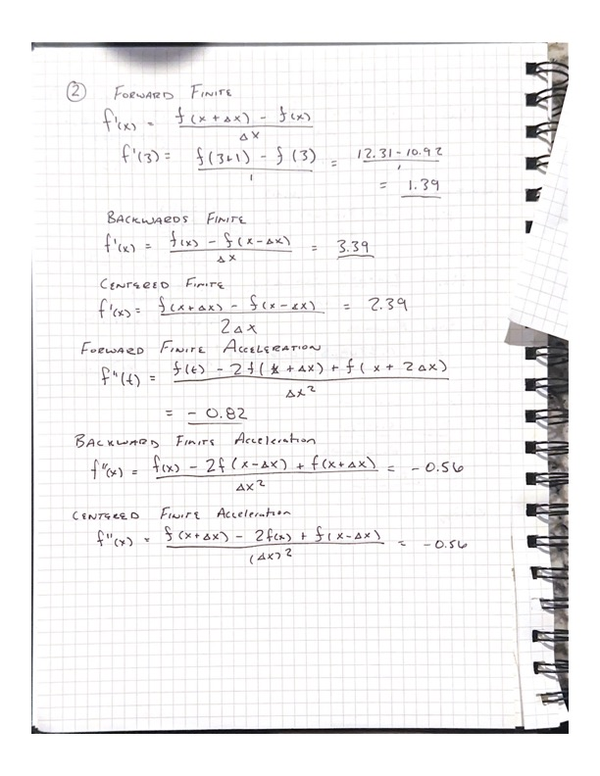

Question 3

Given:

Dynamic viscosity (𝜇) = 1.8 × 10^-5 Ns/m^2

Distances from the surface (𝑦) in meters: [0.000, 0.002, 0.006, 0.012, 0.018, 0.024]

Air velocity (𝑢) in m/s: [0.000, 0.067, 0.572, 2.291, 5.047, 9.041]

Find:

Shear stress 𝜏 at distances 𝑦 = 0.006 m, 0.012 m, and 0.018 m using the second-order centered first finite difference method.

Diagram:

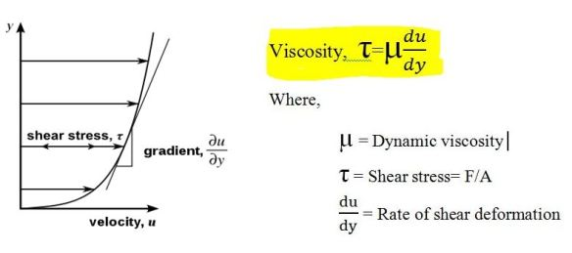

Theory:

Newton's viscosity law relates the shear stress 𝜏 to the dynamic viscosity 𝜇 and the velocity gradient as 𝜏 = 𝜇 * (𝑑𝑢/𝑑𝑦).

Assumptions:

Assume the airflow near the surface is sufficiently steady and incompressible.

Use the provided values for dynamic viscosity and air velocity.

Solution:

Using higher-order methods would likely give you more accurate results, especially if the velocity data is noisy or irregular. These methods provide better approximations for derivatives and could better capture subtle changes in velocity, resulting in more precise estimates of shear stress. However, it may also require more data points for accurate calculations.

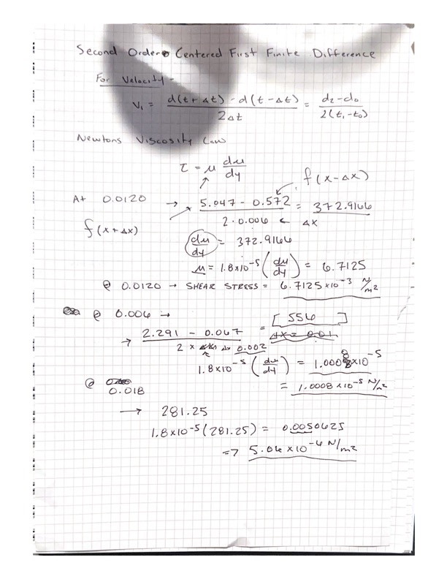

Question 4

Given:

The function: 𝑓(𝑥) = ln(𝑥) sinh(𝑥) / 𝑒^𝑥

Derivative value at 𝑥 = 1.5: 𝑓′(1.5) = 0.336925

Step size: ∆𝑥 = 0.25

Find:

Numerical estimates of the derivative using forward, backward, and centered finite differences.

Percent error between the true value and each estimated value.

Diagram:

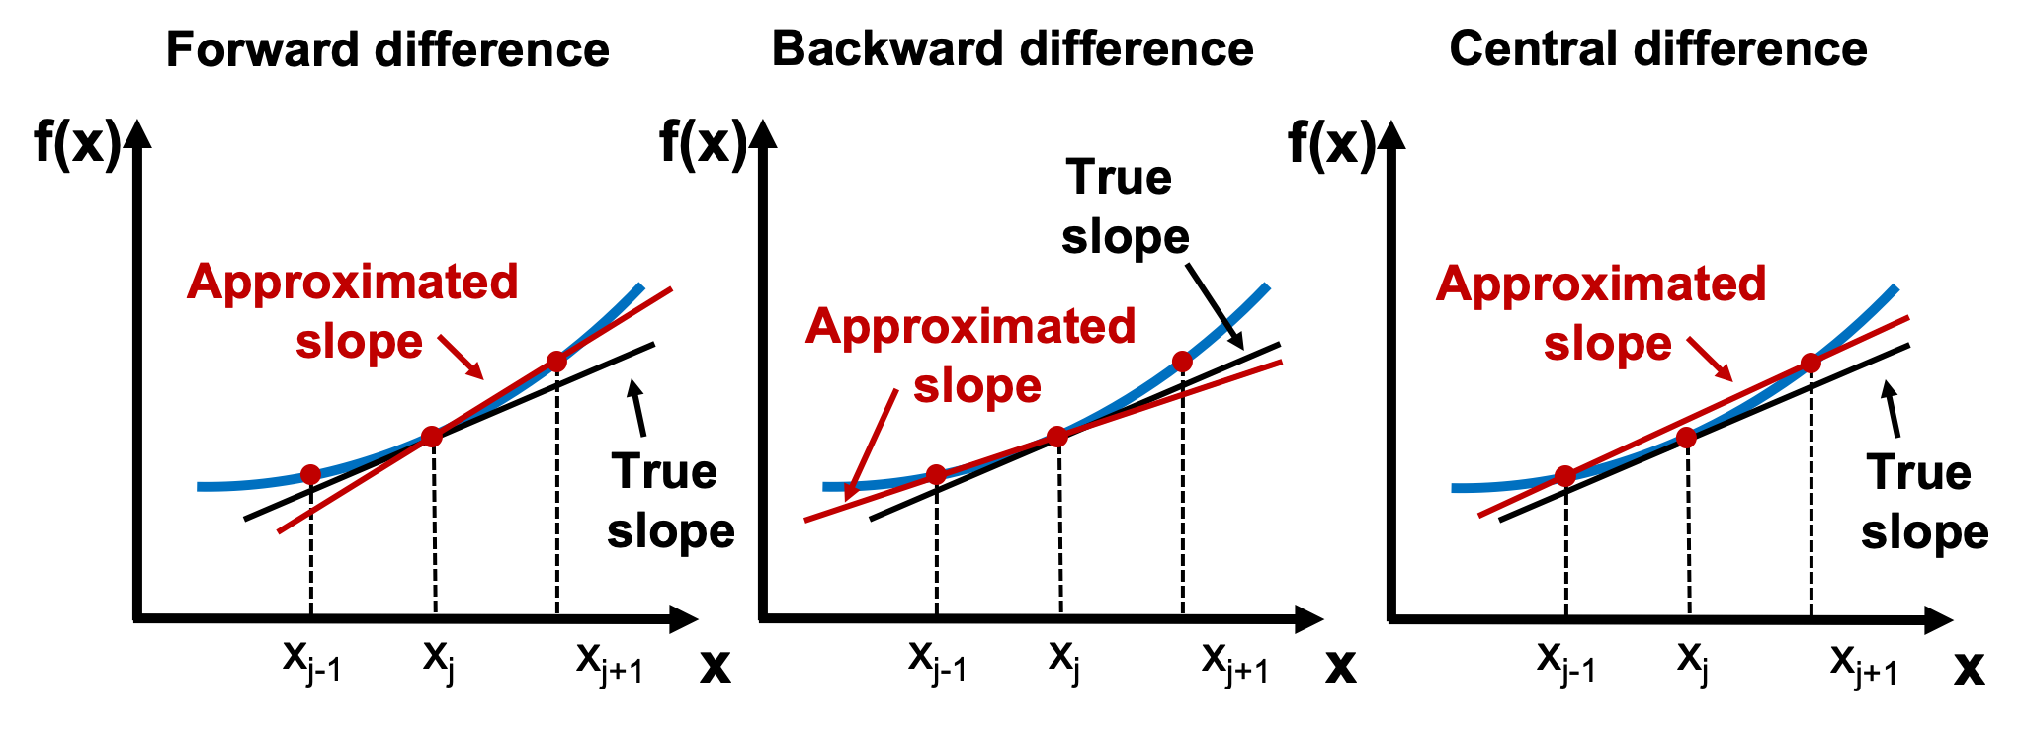

Theory:

* The forward finite difference formula for approximating the derivative is: 𝑓′(𝑥) ≈ [𝑓(𝑥 + ∆𝑥) - 𝑓(𝑥)] / ∆𝑥
* The backward finite difference formula for approximating the derivative is: 𝑓′(𝑥) ≈ [𝑓(𝑥) - 𝑓(𝑥 - ∆𝑥)] / ∆𝑥
* The centered finite difference formula for approximating the derivative is: 𝑓′(𝑥) ≈ [𝑓(𝑥 + ∆𝑥) - 𝑓(𝑥 - ∆𝑥)] / (2∆𝑥)
* Percent error formula: 𝜀 = |𝑡𝑟𝑢𝑒 𝑣𝑎𝑙𝑢𝑒 − 𝑒𝑠𝑡𝑖𝑚𝑎𝑡𝑒𝑑 𝑣𝑎𝑙𝑢𝑒| / |𝑡𝑟𝑢𝑒 𝑣𝑎𝑙𝑢𝑒| × 100%

Assumptions:

The function 𝑓(𝑥) can be accurately approximated using finite differences.

Solution:

